**INDEX**

|  |  |  |
| --- | --- | --- |
| **S.no.** | **Title** | **Page no.** |
| 1. | Introduction | 2 |
| 2. | Literature Review | 3 |
| 3. | Methodology | 4 |
| 4. | Tools | 7 |
|  | 4.1 Software | 7 |
|  | 4.2 Hardware | 8 |
| 5. | System Architecture | 11 |
| 6. | Design | 12 |
|  | 6.1 Overview | 12 |
|  | 6.2 Workflow | 13 |
|  | 6.3 Website | 14 |
|  | 6.4 Android Application | 16 |
|  | 6.5 iOS Application | 17 |
|  | 6.6 MACOSX desktop Application | 18 |
|  | 6.7 Window/Desktop Application | 19 |
| 7. | Data Model | 20 |
| 8. | Conclusion | 23 |
| 9. | Future Scope | 24 |
| 10. | Images With Co-Guide | 25 |

**INTRODUCTION**

AirPrint System is a printing system of this advance era, this machine has a design like an ATM machine, where one can print any document and this system doesn't have any human interference ,this system provides an account to user where one can upload his/her documents through their mobile phones and an e-wallet would be provided from which the total printing charges would be deducted after print operation , this account would have advanced security features , APS also has recycling features in it. Thus, online printing services have appeared to respond to the growth of this new user population. An Android app would be available on play store, through that users would be able to handle their APS account. After the documents are automatically uploaded, a touchscreen interface is used to print the document. In addition, the purpose of the current research is to provide a printing, avoiding the flaws caused between the human and the printer. The proposed system also includes Black and White Printing functions, Color Printing functions, Photo Paper Printing functions. Consequently, the user can print various types of document such as pdf, doc, etc.

**LITERATURE REVIEW**

**Vprint:**

Existing system focuses on print jobs more efficiently but the problem that students are facing is due to blind multiple scanning. Jobs get printed at the specified Printer attached to it only. And sometime it leads to document lost. Student's or users are unable to know how much time to get our print job done? Specified printer print releasing makes and specified server print releasing methodology. At the print release station no effective utilization of the resources because of improper queue monitoring and lack of blind scanning it becomes very tedious and time consuming for students. As the VPRINT accounts crediting process is done manually only this consumes more time and efforts of students. Hence our project is an attempt to overcome such problems.

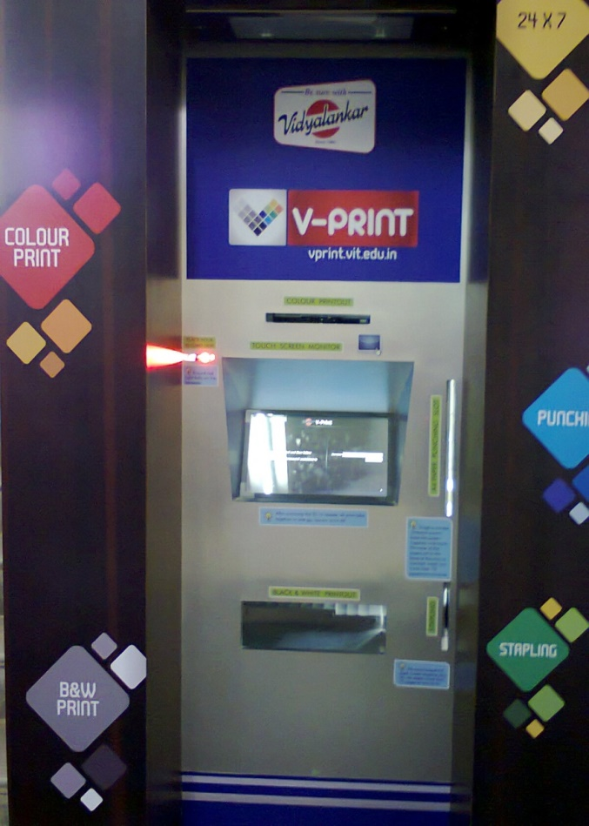

Figure 1: Vprint

|  |  |
| --- | --- |
| **Vprint** | **Airprint** |
| Inconvenient | User Friendly |
| Inconvenient Screen Interface | Touch Screen Interface |
| No Internet Print Portal | Internet Print Portal |
| Only For A4 Size | All Type Of Printing |
| Non Scalable | Scalable |
| No Payment Methods | Payment Gateway |
| No Provision For Recycling | Provision For Recycling |

Figure 2: Comparison between Vprint and AirPrint

**METHOLOGY**

The AirPrint basically works on combination of some of the modern concepts in the world of computer science, AirPrint in all comprises IOT, Networking, Linux, Android /iOS/Java application development and Web development concepts.

**Architecture of AirPrint**

* AirPrint application runs on Raspberry pi 2(IOT developer board/credit card size computer).
* It has a touch screen display of 7 inches interface compatible with Raspberry pi.
* A CPU which acts local as a server for AirPrint.
* Numeric Keypad used at the time of Authentication.
* A printer to print the documents on A4 size paper.

**Printing Mechanism**

It was a challenge to count the number of pages in the document before printing it ,so this problem was solved using Linux command to count pages in a document further this mechanism carries out the printing process if the user has sufficient balance in his/her account or else it asks the user to credit their account.

**User’s Database**

This database contains all the information of every single user who has registered on AirPrint portal. This database also contains the information about the balance credited or debited by the user.

**AirPrint Portal**

This portal is divided into two parts

1. Web Application.

The web application is used for registration, authentication, file uploading and payment gateway purpose. One can run its link in their browser and then they can use the features of this app.

Android & iOS application is also developed which in turn works as web application.

1. Java Application.

The Java application is used for only Authentication and further printing process. This application would be running on Raspberry pi-2 24x7 and one would be able to authenticate and take printouts

from AirPrint dashboard which would contain files they uploaded from web app or android/iOS/windows app.

**Multiple Platforms**

We have developed applications for the platforms, iOS, Android, Windows through which the user can register on AirPrint portal, Login to the portal, upload his/her files or credit the money into his or her AirPrint account.

**Bots**

If any user wants to forward the file through the Mail or Message then he/she can forward these files to Gmail/Telegram bot of AirPrint which in turn places the files automatically to user’s AirPrint dashboard from where user can easily print these files.

**TOOLS**

1. Hardware Tools
   1. Raspberry Pi 2 Model B+

Here is the full list of specs for Raspberry Pi 2 Model B:

* SoC: Broadcom BCM2836 (CPU, GPU, DSP, SDRAM)
* CPU: 900 MHz quad-core ARM Cortex A7 (ARMv7 instruction set)
* GPU: Broadcom Video Core IV @ 250 MHz
* More GPU info: OpenGL ES 2.0 (24 GFLOPS); 1080p30 MPEG-2 and VC-1 decoder (with license); ​1080p30 h.264/MPEG-4 AVC high-profile decoder and encoder
* Memory: 1 GB (shared with GPU)
* USB ports: 4
* Video input: 15-pin MIPI camera interface (CSI) connector
* Video outputs: HDMI, composite video (PAL and NTSC) via 3.5 mm jack
* Audio input: I²S
* Audio outputs: Analog via 3.5 mm jack; digital via HDMI and I²S
* Storage: MicroSD
* Network: 10/100Mbps Ethernet
* Peripherals: 17 GPIO plus specific functions, and HAT ID bus
* Power rating: 800 mA (4.0 W)
* Power source: 5 V via Micro USB or GPIO header
* Size: 85.60mm × 56.5mm
* Weight: 45g (1.6 oz)
  1. Memory Card [16GB]

Secure Digital is a non-volatile memory card format developed by the SD Card Association for use in portable devices. The standard was introduced in August 1999 by joint efforts between SanDisk, Panasonic and Toshiba as an improvement over Multimedia Cards, and has become the industry standard.

* 1. Touchscreen Display

Touch Screen Display Solutions from Desktop Monitors to Video Walls. Planar is a leader in durable, vibrant touch screen display solutions providing a range of high-quality solutions across a spectrum of interactive technologies

* 1. Printer

We are using HP Deskjet 1112. With we help of this, user can take printout of their work.

* 1. PC
  2. Numeric Keypad

A numeric keypad, number pad, numpad, or ten key, is the palm-sized, 17-key section of a standard [computer keyboard](https://en.wikipedia.org/wiki/Computer_keyboard), usually on the far right. With the help of this user are able to login his account.

1. Software Tools
   1. CUPS

CUPS is the standards-based, open source printing system developed by Apple  for macOS and other UNIX -like operating systems. CUPS uses the Internet Printing Protocol (IPP) to support printing to local and network printers

* 1. PyKota v1.27

The purpose of using PyKota is helps us to take the control of printing system. PyKota is one of the most advanced Open Source Software dedicated to print accounting and print quota enforcement. It is a full featured, internationalized, centralized, and extensible print quota system for CUPS.

* 1. Apache Derby

[Apache Derby](http://db.apache.org/derby), an [Apache DB subproject](http://db.apache.org/), is a relational database implemented in Java. Its footprint is so small you can easily embed it in any Java-based solution. In addition to its embedded framework, Derby supports a more familiar client/server framework with the Derby Network Server. This tutorial introduces Derby's basic features and walks you through using both frameworks; first the embedded framework using the Derby Embedded JDBC driver, then the Network Server framework using the Derby Network Client JDBC driver.

* 1. Google Cloud Print Connector

This allows users in your organization to print to your legacy printer(s) from Chrome devices and other web-enabled devices. Running the connector as a service means that Cloud Print is always on—running on your organization's servers.

* 1. Ngrok tunnel

Public URLs for testing your chatbot. Public URLs for demoing from your own machine.

* 1. Pkpgcounter

pkpgcounter is a generic Page Description Language parser which can either count the number of pages or compute the percent of ink coverage needed to print various types of documents. pkpgcounter is both a command line tool and a Python library distributed under the terms of the [GNU General Public License of the Free Software Foundation, version 3 or higher](http://www.pykota.com/GPL3).

* 1. Pkipplib

Pkipplib is a Python library which can prepare IPP requests with the help of a somewhat high level API. These requests can then be sent to an IPP printer or print server (e.g. CUPS).This library can also parse IPP answers received, and create high level Python objects from them. Both of these actions can be done through an IPP Request class and its instance methods. Finally, a CUPS class can be leveraged to easily deal with CUPS print servers. This entire library being written in the Python language, there's no need to link the code with the CUPS' API, which makes it independent of the CUPS version being installed. Some command line tools which rely on pkipplib are now included.

* 1. jQuery Core

JQuery is a fast, small, and feature-rich JavaScript library. It makes things like HTML document traversal and manipulation, event handling, animation, and Ajax much simpler with an easy-to-use API that works across a multitude of browsers. With a combination of versatility and extensibility, jQuery has changed the way that millions of people write JavaScript.

* 1. NetBeans

NetBeans is an integrated development environment for Java. NetBeans allows applications to be developed from a set of modular software components called modules. NetBeans runs on Microsoft Windows, macOS, Linux and Solaris

* 1. Android Studio

Android Studio is the official integrated development environment for Google's Android operating system, built on Jet Brains' IntelliJ IDEA software and designed specifically for Android development. It is available for download on Windows, macOS and Linux based operating systems.

**SYSTEM ARCHITECTURE**

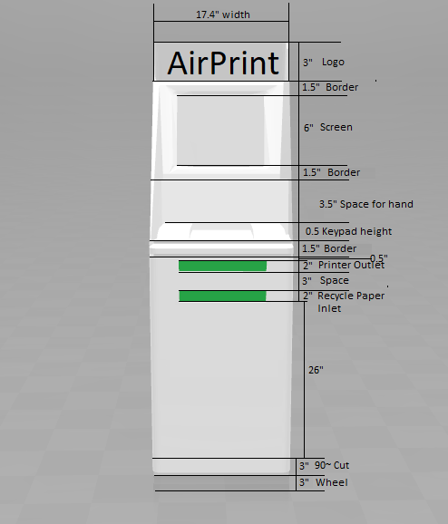 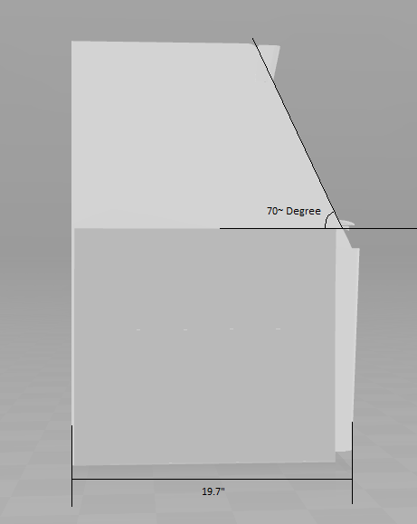

Figure 3: Architecture

**DESIGN**

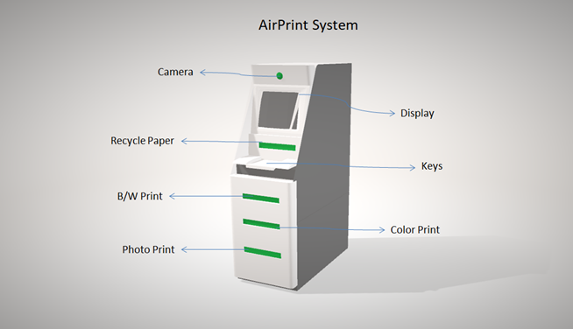

Figure 4: Design

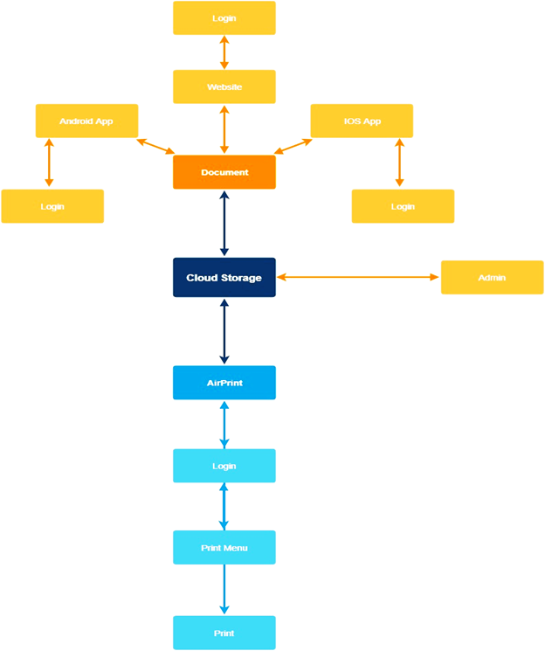

Figure 5: Workflow

**WEBSITE**

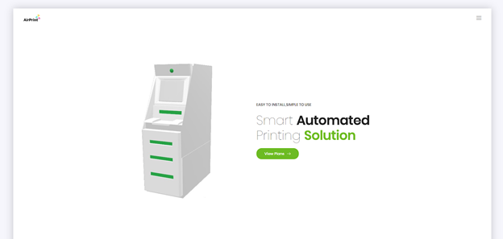

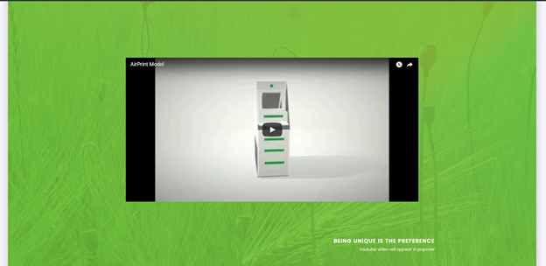

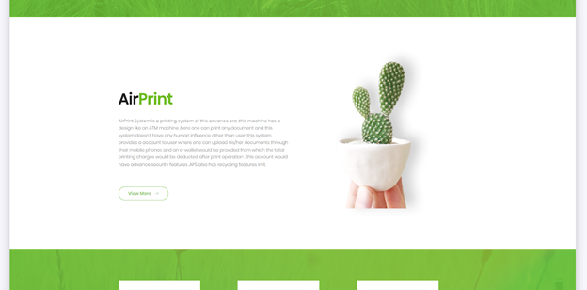

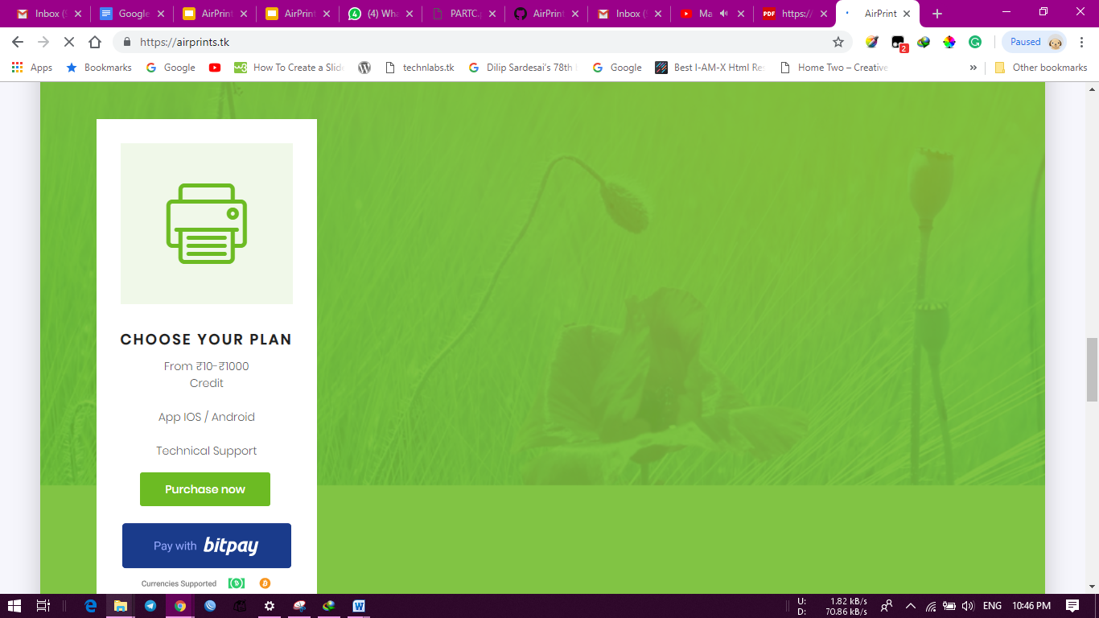

**ANDROID APPLICATION**

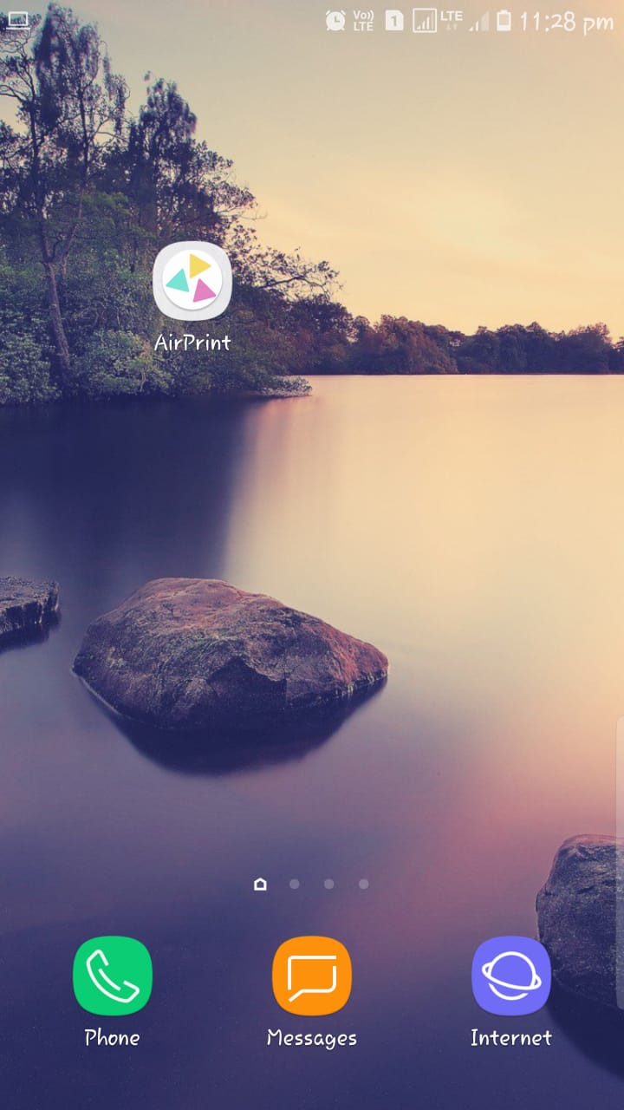 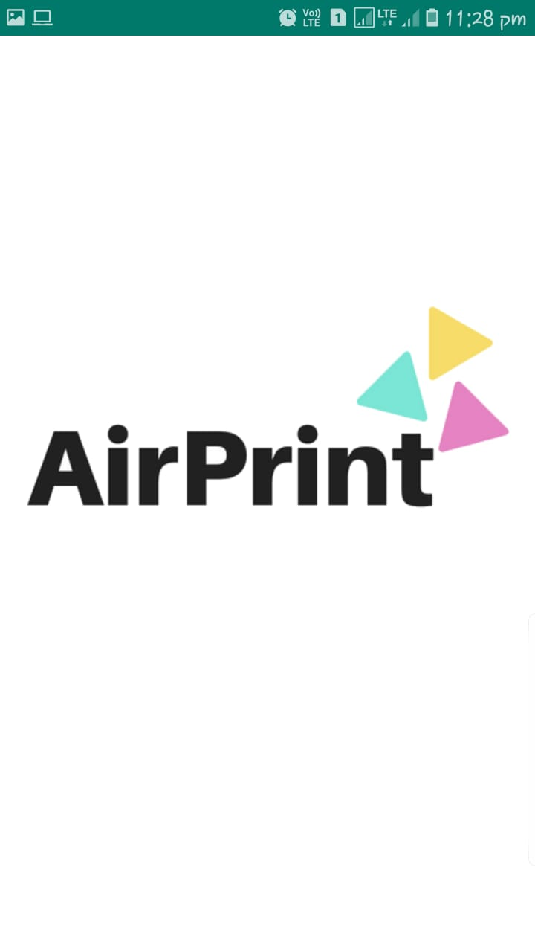

Fig 5: App Logo Fig 6: Splash Screen

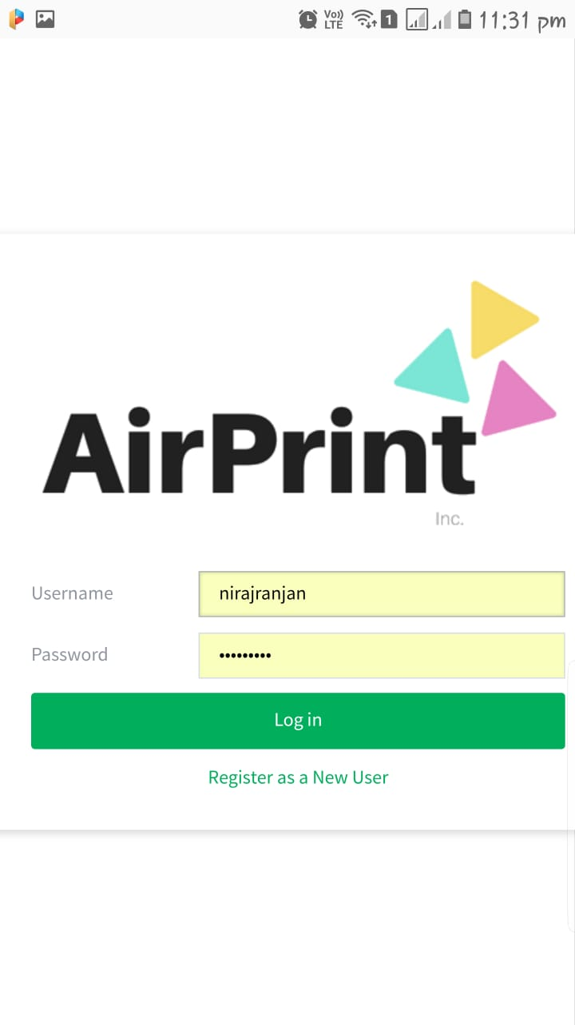 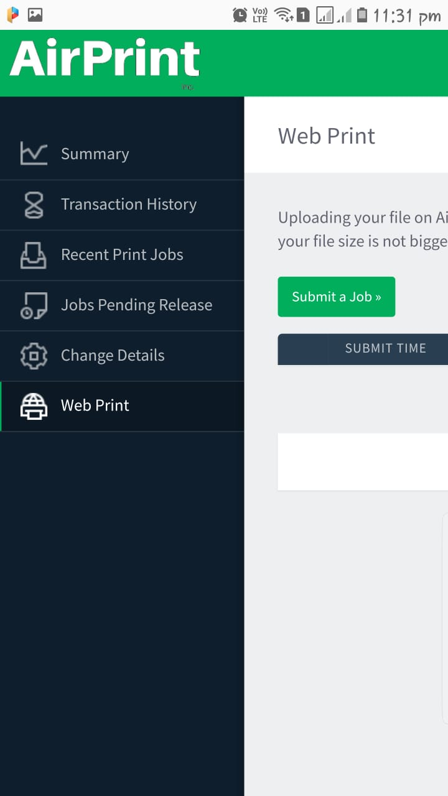

Fig 7: Login Screen Fig 8: User Account

**IOS APPLICATION**

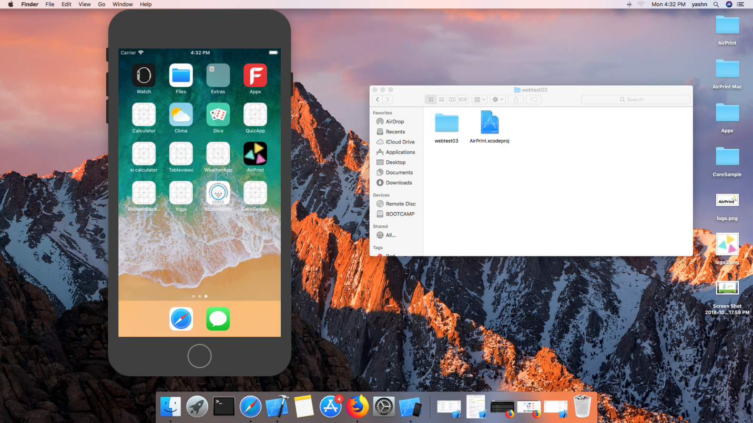

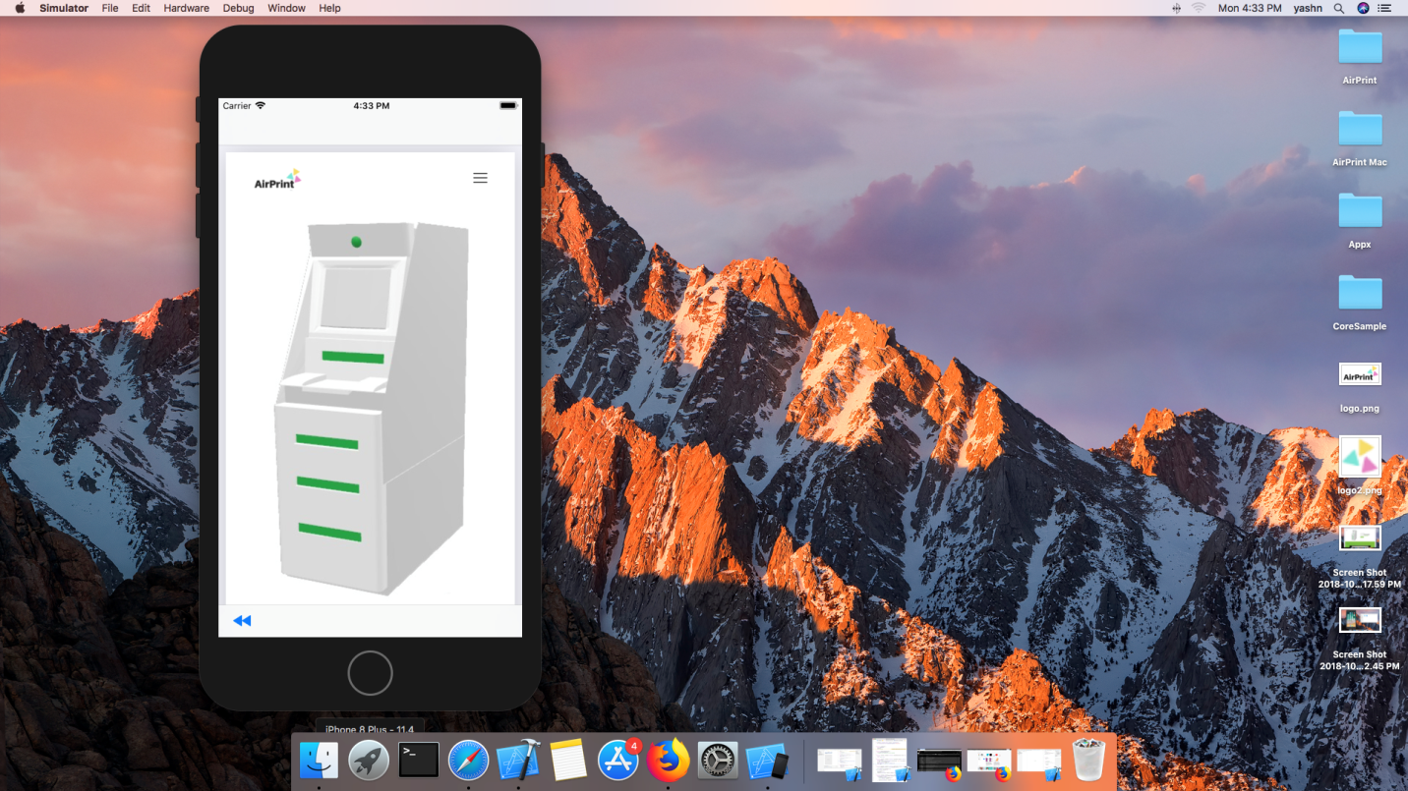

**MACOSX DESKTOP APPLICATION**

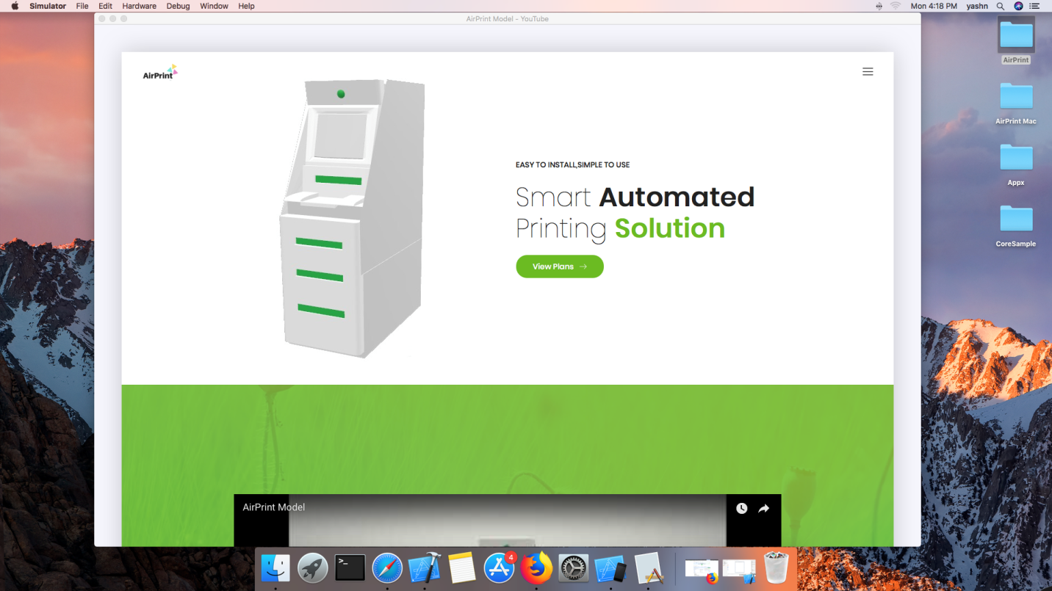

**WINDOW/DESKTOP APPLICATION**

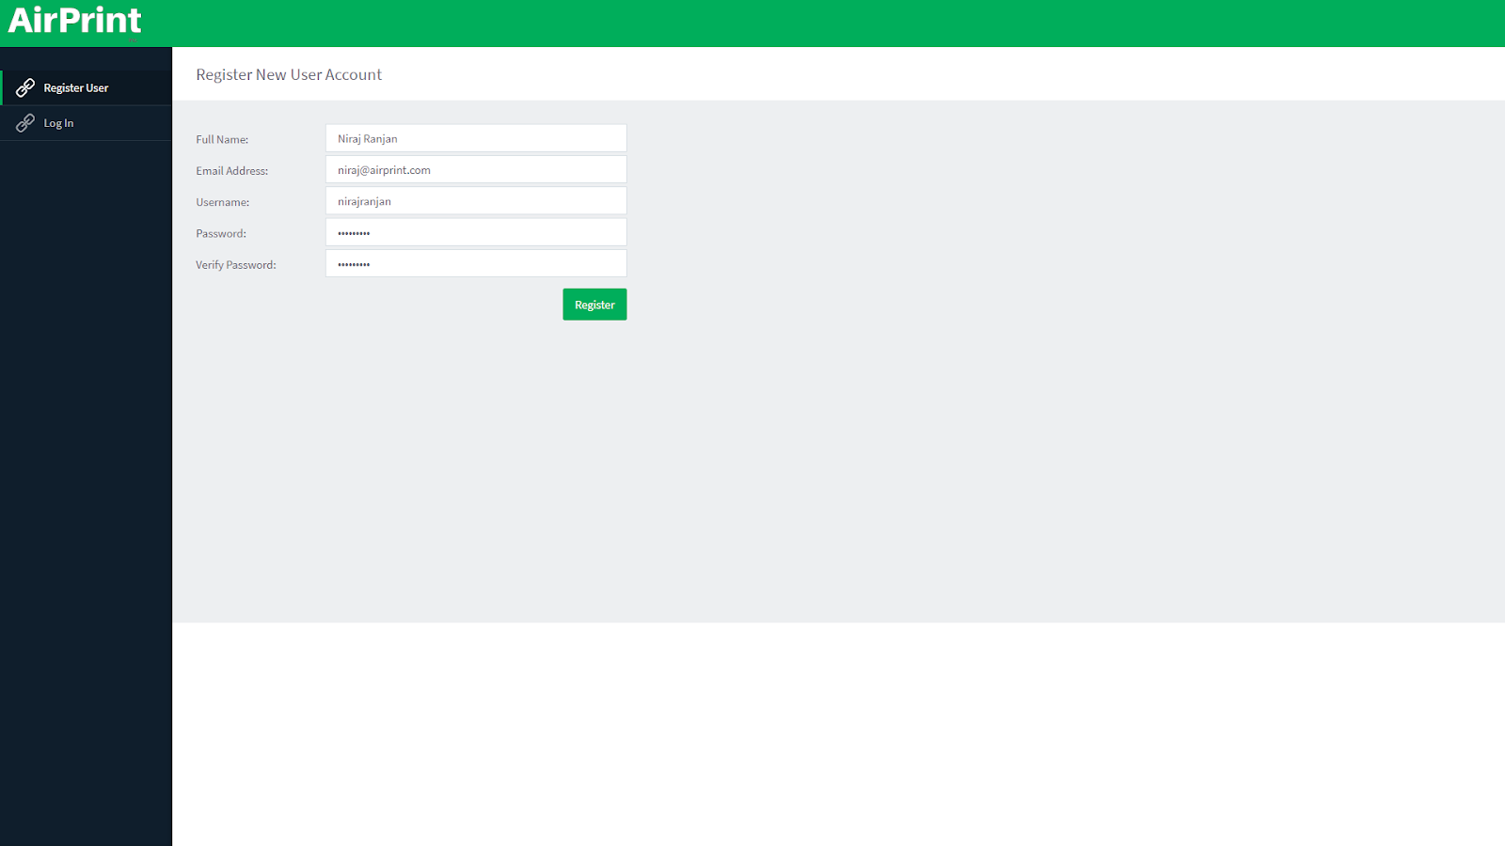

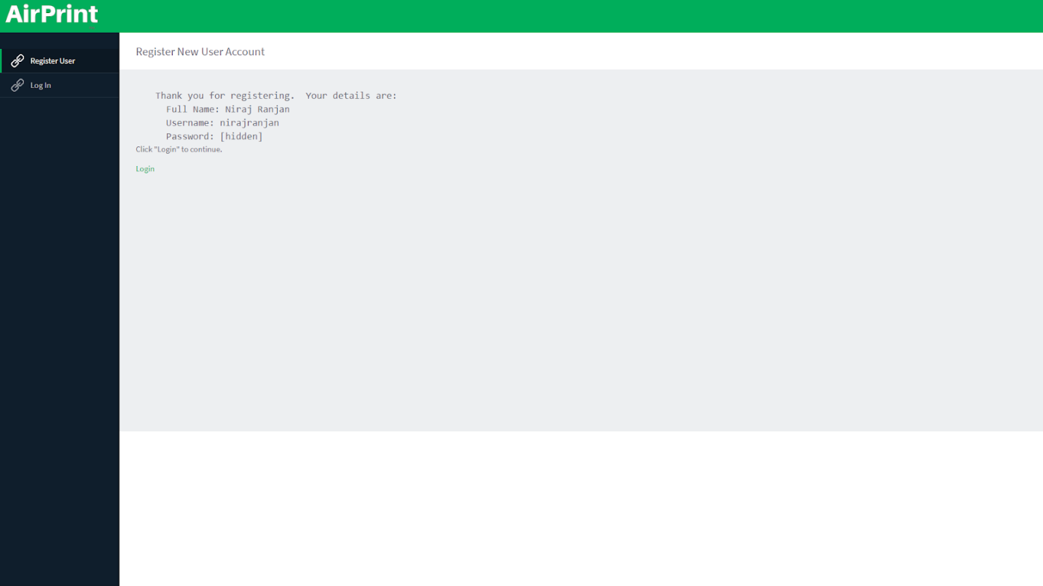

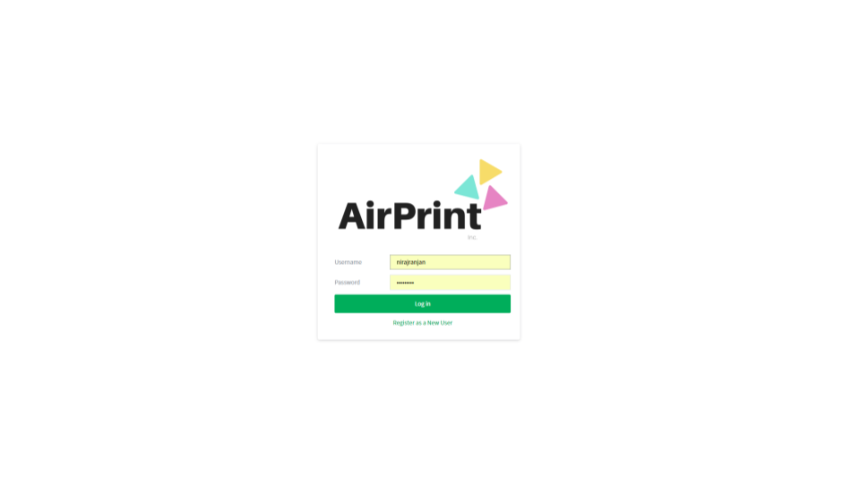

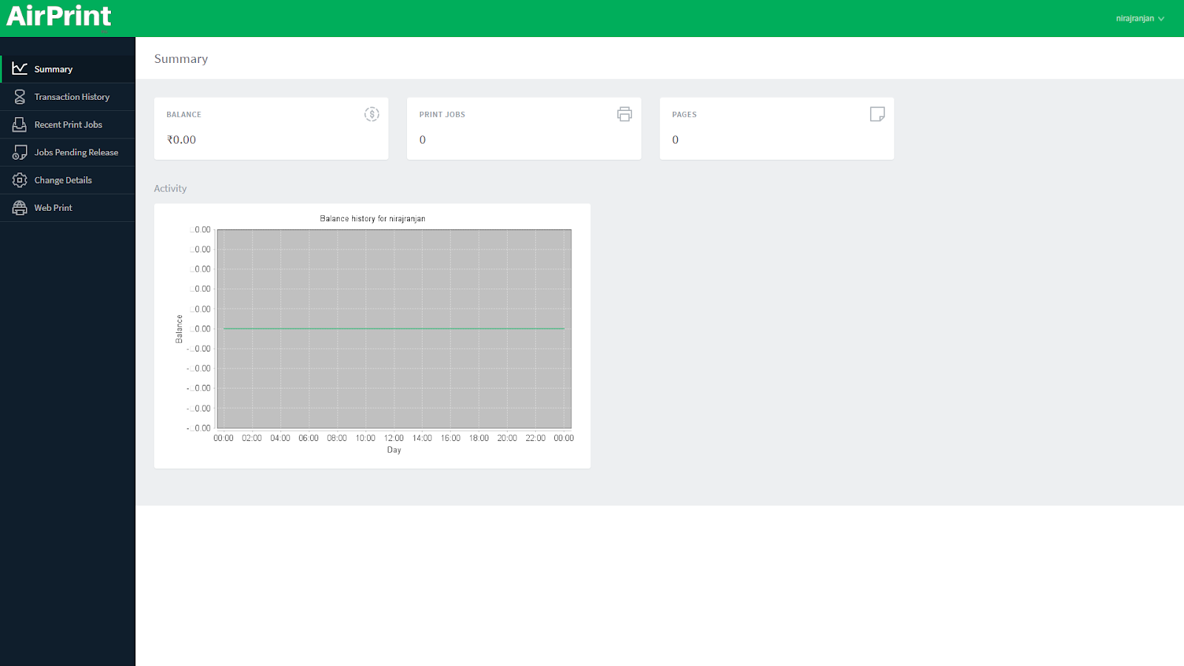

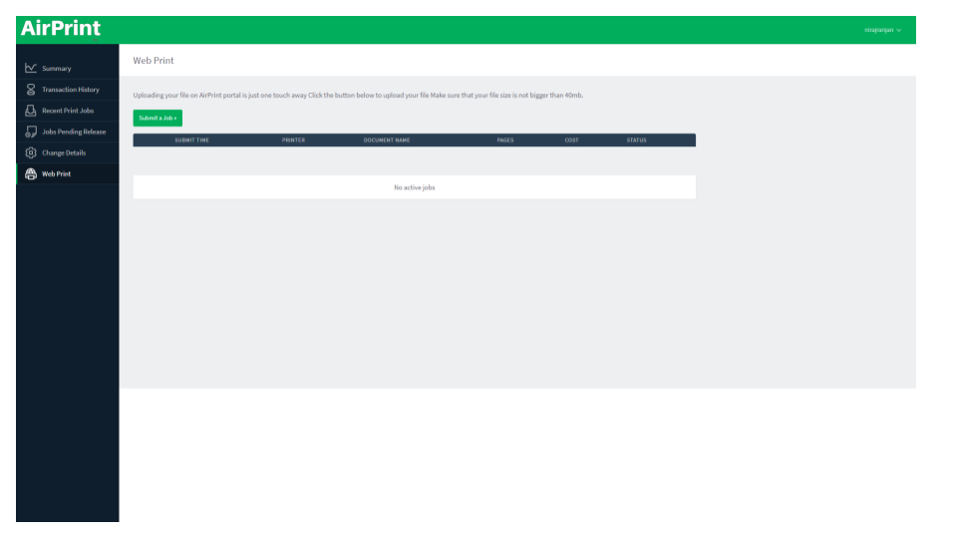

**DATA MODEL**

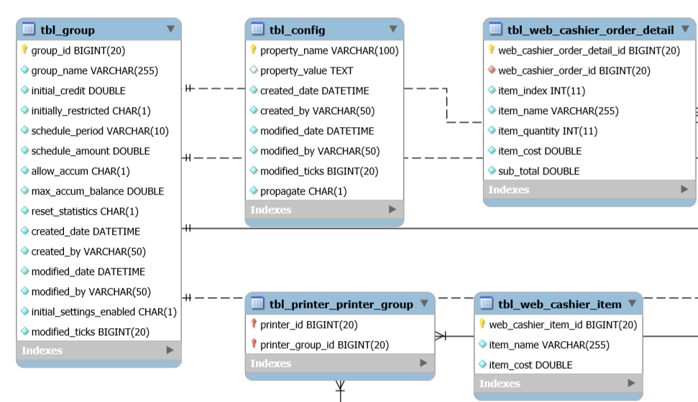

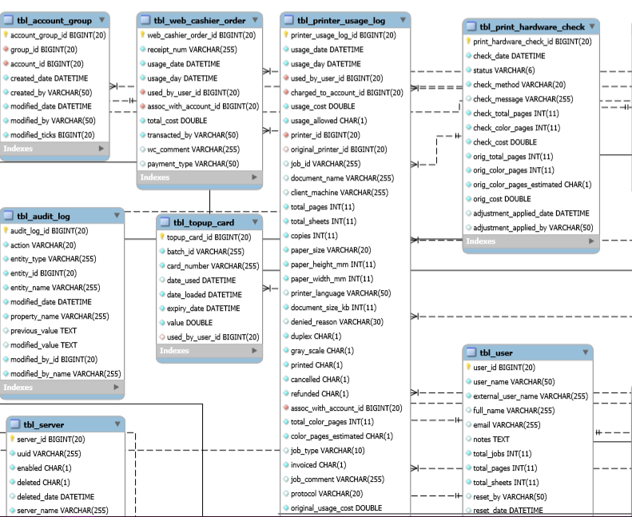

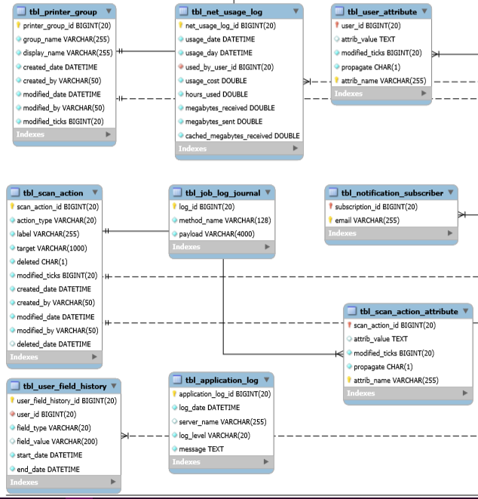

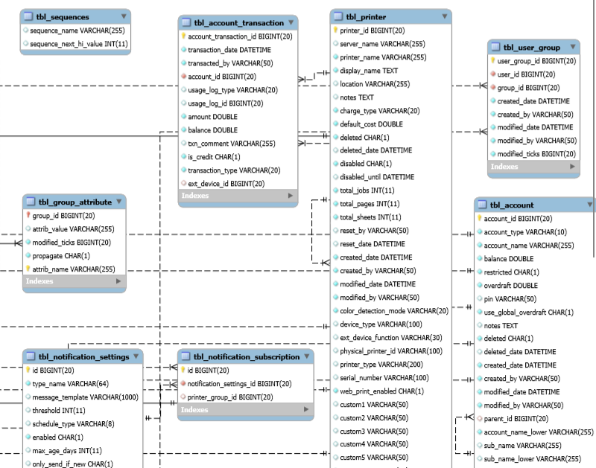

**CONCLUSION**

This work described web-based printing system with significant features allows users to save their time. Associated features of the system make it maximum utilization. As Queue Monitoring, Centralized server Print Releasing and for online transactions E- wallet is congaed.

It is our privilege to express our sincerest regards to our project guide, Prof. Piyush Ingole for his valuable inputs, able guidance, encouragement and constructive criticism throughout the duration of our project. We thank our college for providing us with excellent facilities that helped us to work on the project. We would also like to thank the staff members and lab assistants for permitting us to use computers in the lab as and when required. We express our deepest gratitude towards our project guide for his valuable and timely advice during the various phases in our project. Finally we would like to thank everyone who helped us directly or indirectly in our project.

**FUTURE SCOPE**

* Cashless Printing.
* It uses is so many places as:
  + Usage
  + Colleges
  + Schools
  + Airports
  + Hotels
  + Shopping Mall
  + Commercial buildings
  + Government Office
  + Office Building

**REFERENCES**

* G. C. Sacket and C. Y. Metz, "ATM and Multiprotocol Networking," McGraw-Hill, 1996.
* H. Dutton and Peter Lenhard, "Asynchronous Transfer Mode (ATM) Technical Overview," 2nd Ed., Prentice Hall, 1995.
* B. Dorling, D. Freedman, C. Metz, and J. Burger, "Internetworking over ATM: An Introduction," Prentice Hall, 1996.
* S. Siu and R. Jain, "A brief overview of ATM: Protocol Layers, LAN Emulation and Traffic Management" Computer Communications Review (ACM SIGCOMM), April 1995. Available at <http://www.cse.wustl.edu/~jain/papers/atm_tut.html>
* CUPS ([http://www.cups.org](http://www.cups.org/))
* PyKota v1.27 ([www.pykota.com](http://www.pykota.com/))
* Automatic Paper Counting Machine (<http://www.ijste.org/articles/IJSTEV2I10167.pdf>)
* Google Cloud Print Connector (<https://github.com/yugn27/cloud-print-connector>)

IMAGES WITH CO-GUIDE